**MODULE 5**

Transport service – Services provided to the upper layers, Transport service primitives. User Datagram Protocol (UDP). Transmission Control Protocol (TCP) – Overview of TCP, TCP segment header, Connection establishment &release, Connection management modeling, TCP retransmission policy, TCP congestion control.

Application Layer –File Transfer Protocol (FTP), Domain Name System (DNS), Electronic mail, Multipurpose Internet Mail Extension (MIME), Simple Network Management Protocol (SNMP), World Wide Web(WWW) – Architectural overview.

**Questions**

1. What are the basic functions supported by an e-mail?

## Composition,Transfer,Reporting,Displaying,Disposition

1. When Web pages are sent out, they are prefixed by MIME headers. Why?
2. Explain SMTP and its working
3. Describe mail access protocols POP and IMAP
4. Explain architectural overview of WWW
5. Explain SNMP basic components and their functions. Describe the basic

commands used in SNMP.

* SNMP basic components- SNMP manager,SNMP agent, Management information base
* Basic commands- GetRequest ,GetNextRequest,**Getbulk Request: ,**SetRequest, GetResponse, Trap.,InformRequest: ,Report

**ELECTRONIC MAIL**

* Electronic Mail (e-mail) is one of most widely used services on the Internet.
* This service allows an Internet user to send a message in formatted manner (mail) to the other Internet user in any part of the world.
* Messages in mail not only contain text, but it also contains images, audio and videos data.
* The person who is sending mail is called the sender and the person who receives mail is called recipient.
* It is just like postal mail service.

# **FUNCTIONS**

The E-mail system supports five basic systems, which are as follows:

## Composition

1. **Transfer**
2. **Reporting**
3. **Displaying**
4. **Disposition**

## Composition

The process of generating messages and answering them is called composition. The system can also support assistance with addressing and several header fields attached to each message.

## Transfer

It is the process of moving messages from the sender to the recipient. This includes establishing a connection from the sender to a destination or some intermediate machine, outputting the message and releasing the connection.

## Reporting

This is to tell the sender whether the message was delivered or rejected, or lost.

## Displaying

It is the process of displaying incoming messages. For this purpose, simple conversation and formatting are required to be done.

## Disposition

This is concerned with what the recipient does with the messages after receiving them. Some of the possibilities are as follows −

* + Throw after reading
  + Throw before reading
  + Save messages
  + Forward messages
  + Process messages in some other way

**COMPONENTS OF EMAIL**

The following are the essential components of an e-mail system:

1. User Agent (UA)

2. Message Transfer Agent (MTA)

3. Message Access Agent

**User Agent (UA)**

The User-Agent is a simple software that sends and receives mail. It is also known as a mail reader. It supports a wide range of instructions for sending, receiving, and replying to messages and manipulating mailboxes.

Some of the services supplied by the User-Agent are listed below:

● Reading a Message

● Sending a reply to a Message

● Message Composition

● Forwarding a Message

● Handling the Message

**Message Transfer Agent(MTA)**

* The actual mail transfer is done through message transfer agents (MTAs).
* To send mail, a system must have the client MTA, and to receive mail, a system must have a server MTA.
* The formal protocol that defines the MTA client and server in the Internet is called **Simple Mail Transfer Protocol (SMTP).**
* Simple Mail Transfer Protocol sends messages from one MTA to another.

**Message Access Agent**

* POP and IMAP4 are the two protocols used to access messages.

**SMTP**

* The primary purpose of SMTP is to transfer email between mail servers.
* To send email, the client sends the message to an outgoing mail server, which in turn contacts the destination mail server for delivery.
* For this reason, it is necessary to specify an SMTP server when configuring an email client.
* One important point to make about the SMTP protocol is that it does not require authentication.
* This allows anyone on the Internet to send email to anyone else or even to large groups of people

**Working of SMTP**

1. Sender provides receiver 's e-mail address and composes its message.
2. Sender sends the message to its mail server.
3. Server of Sender places the message in its queue
4. SMTP on Sender 's mail server notices the message in the queue and opens a TCP connection with the user receiver’s mail server.
5. Initial SMTP handshaking takes place between the two servers.
6. The message is sent to receiver 's mail server, using the established TCP connection.
7. receiver 's mail server receives the message and then puts it in receiver 's mailbox, ready to be retrieved by receiver

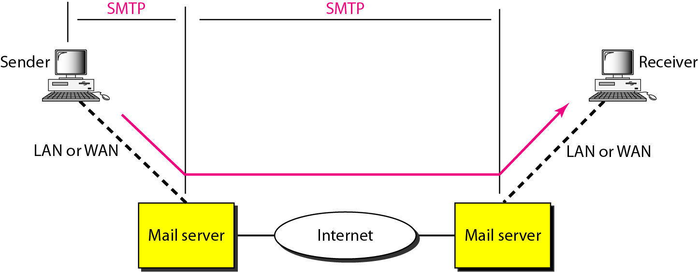

* SMTP is a protocol to transfer mails
* It defines the MTA client and server in the Internet
* SMTP defines how commands and responses must be sent back and forth between MTA client and server.

***Commands and Responses***

* SMTP uses commands and responses to transfer messages between an MTA client and
* an MTA server
* Commands sent from the client to the server
* Responses are sent from the server to the client

**MAIL MESSAGE FORMAT**

### The actual message inside the envelope is made of two parts

* + - Header

### Body

The header carries the control information while the Body contains the message contents. The envelope and messages are shown in the figure below −

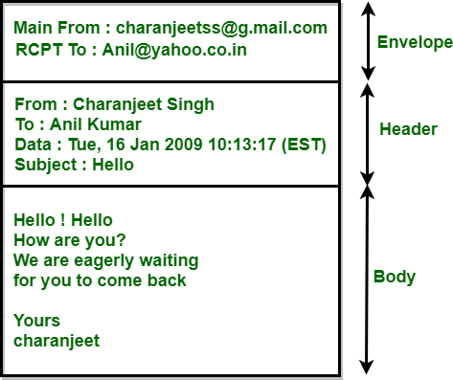

Messages consist of a primitive envelope, some header fields and a blank line, and the message body. Each header field logically includes a single line of ASCII text which contains the field name, a colon and a field. RFC 822 is an old standard.

Usually, the user agent builds a message and passes it to be the message transfer agent with the user’s header fields to construct an envelope.

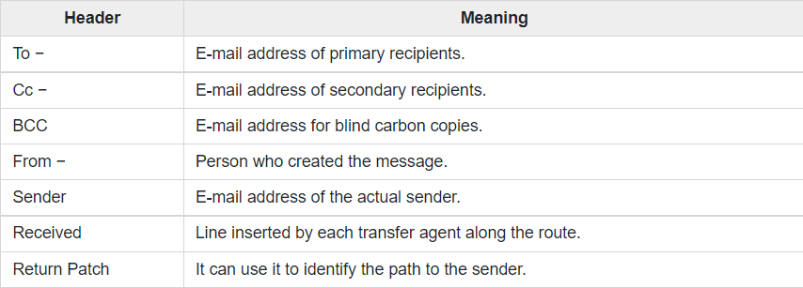The following table shows the principal header fields related to message transport. RFC 822 header fields related to message transport

**The To − field**

The field gives the DNS address of the primary recipient. It is allowed to have multiple recipients.

## The Cc − field

This field gives the addresses of any secondary recipients.

## The Bcc

The long form of Bcc is Blind Carbon Copy. This field is such as the Cc field, except that this is removed from all the copies shared with the primary and secondary recipients. This feature allows people to send copies to third parties without primary and secondary recipients knowing this.

## From − and Sender fields

These fields tell about who wrote the message and who sent the message,

respectively, because the person who creates the message and the person who sends it can be different.

## Received field

A-line containing the Received field is added by each message transfer agent along the way. This line carries the agent’s identity, date and time at which they received the message. It also contains some other information that can be used to find bugs in the routing system.

## The Return-Path− field

The final message transfer agent adds this field, and it is predetermined to tell how to receive back to the sender. It can gather this information from all the received headers.

## Other header fields

In addition to the field to table below, RFC 822 messages may contain various header fields used by user agents or human recipients. Many of them are shown in the table below

Some fields in RFC 822 message header are as follows :

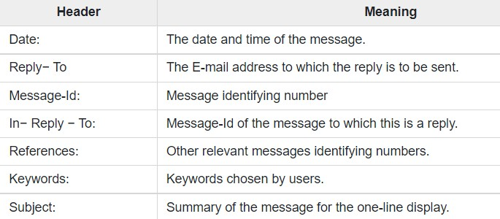

## Message Body

The message body comes after the header. The users can put whatever they want to send in the message body. It is possible to terminate the messages with ASCII cartoons, quotations, and political statements.

**Mail Access Protocols**

There are two primary protocols used by email client applications to retrieve email from mail servers: the ***Post Office Protocol* (*POP*) and the *Internet Message Access Protocol* (*IMAP*).**

Unlike SMTP, both of these protocols require connecting clients to authenticate using a username and password. By default, passwords for both protocols are passed over the network unencrypted.

***POP3***

* Post Office Protocol, version 3 (POP3) is simple and limited in functionality.
* The client POP3 software is installed on the recipient computer; the server POP3 software is installed on the mail server.
* Mail access starts with the client when the user needs to download e-mail from the mailbox on the mail server.
* The client opens a connection to the server on TCP port 110.
* It then sends its user name and password to access the mailbox.
* The user can then list and retrieve the mail messages, one by one.

***MODES OF POP3***

* POP3 has two modes: **the delete mode and the keep mode**. In the delete mode, the mail is deleted from the mailbox after each retrieval.
* In the **keep mode**, the mail remains in the mailbox after retrieval.
* The **delete mode** is normally used when the user is working at her permanent computer and can save and organize the received mail after reading or replying.
* The keep mode is normally used when the user accesses her mail away from her primary computer (e.g., a laptop).
* The mail is read but kept in the system for later retrieval and organizing

***IMAP(*Internet Mail Access Protocol )**

* Another mail access protocol is Internet Mail Access Protocol
* IMAP is similar to POP3, but it has more features
* IMAP4 is more powerful and more complex.

**IMAP4 provides the following extra functions:**

* A user can check the e-mail header prior to downloading.
* A user can search the contents of the e-mail for a specific string of characters prior to downloading.
* A user can partially download e-mail. This is especially useful if bandwidth is limited and the e-mail contains multimedia with high bandwidth requirements.
* A user can create, delete, or rename mailboxes on the mail server.
* A user can create a hierarchy of mailboxes in a folder for e-mail storage.

**Difference between POP3 & IMAPv4**

* POP3 is deficient in several ways
* POP3 does not allow the user to organize her mail on the server
* POP3 does not allow the user to partially check the contents of mail before downloading
* With IMAP4, the user can check the e-mail header prior to downloading
* With IMAP4, the user can search the contents of the e-mail for a specific string of characters prior to downloading
* With IMAP4, the user can partially download e-mail

**MIME - MULTIPURPOSE INTERNET MAIL EXTENSION**.

* MIME stands for MULTIPURPOSE INTERNET MAIL EXTENSION.
* It was proposed by Bell Communications in 1991 in order to expand the limited capabilities of email.
* MIME is a kind of add-on or a supplementary protocol that allows non-ASCII data to be sent through SMTP.
* It basically transforms the non-ASCII data at the sender site and then delivers them to the client in order to be sent through the Internet.
* It allows the users to exchange different kinds of data files on the Internet: audio, video, images, application programs as well.
* MIME is basically a set of software functions that mainly transforms the Non-ASCII data to ASCII data and vice-versa.

## NEED OF MIME

* MIME protocol is used to transfer e-mail in the computer network for the following reasons:
* The MIME protocol supports multiple languages in e-mail, such as Hindi, French, Japanese, Chinese, etc.
* Simple protocols can reject mail that exceeds a certain size, but there is no word limit in MIME.
* Images, audio, and video cannot be sent using simple e-mail protocols such as SMTP. These require MIME protocol.
* Many times, emails are designed using code such as HTML and CSS, they are mainly used by companies for marketing their product. This type of code uses MIME to send email created from HTML and CSS.

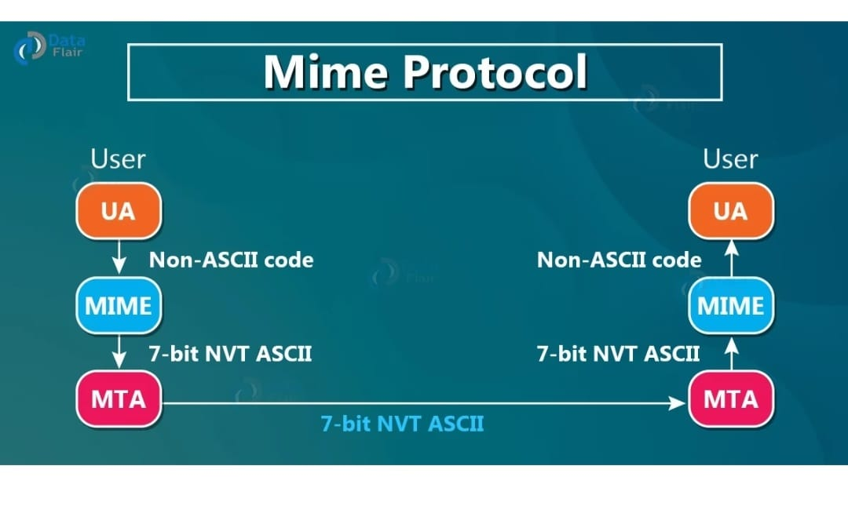

* Let us take an example where a user wants to send an Email through the user agent, and this email is in a non-ASCII format.
* So here we use the MIME protocol that mainly converts this non-ASCII format into the 7-bit NVT ASCII format.
* The message is transferred via email system to the other side in the 7-bit NVT ASCII format and then again the MIME protocol will convert it back into the Non-ASCII code.
* At the receiver side so that receiver can read it.

At the beginning of any email transfer basically, there is an insertion of the MIME header

**FEATURES OF MIME**

* It is able to send multiple attachments with a single message.
* Unlimited message length.
* MIME provided support for varying content types and multi-part messages.
* Binary attachments (executables, images, audio, or video files) may be divided if needed.
* MIME supports the character set other than ASCII.
* It also provides support for non-textual content in the email message.
* It also supports layouts, fonts and colours which are categorized as rich text.

## MIME HEADER

The MIME header is mainly added to the original e-mail header section in order to define the transformation. Given below are five headers that are added to the original header:

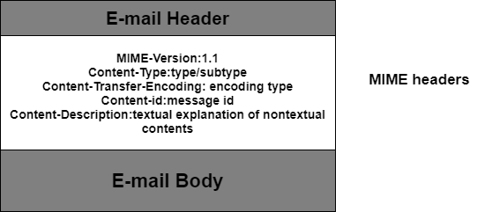

1. MIME Version
2. Content Type
3. Content Type Encoding
4. Content Id
5. Content Description

### **MIME Version**

It defines the version of the MIME protocol. This header usually has a parameter value 1.0, indicating that the message is formatted using MIME.

### **Content Type**

It describes the type and subtype of information to be sent in the message. These messages can be of many types such as Text, Image, Audio, Video, and they also have many subtypes such that the subtype of the image can be png or jpeg. Similarly, the subtype of Video can be WEBM, MP4 etc.

### **Content Type Encoding**

In this field, it is told which method has been used to convert mail information into ASCII or Binary number, such as 7-bit encoding, 8-bit encoding, etc.

### **Content Id**

In this field, a unique "Content Id" number is appended to all email messages so that they can be uniquely identified.

### **Content description**

This field contains a brief description of the content within the email. This means that information about whatever is being sent in the mail is clearly in the "Content Description". This field also provides the information of name, creation date, and modification date of the file.

## WORKING OF MIME

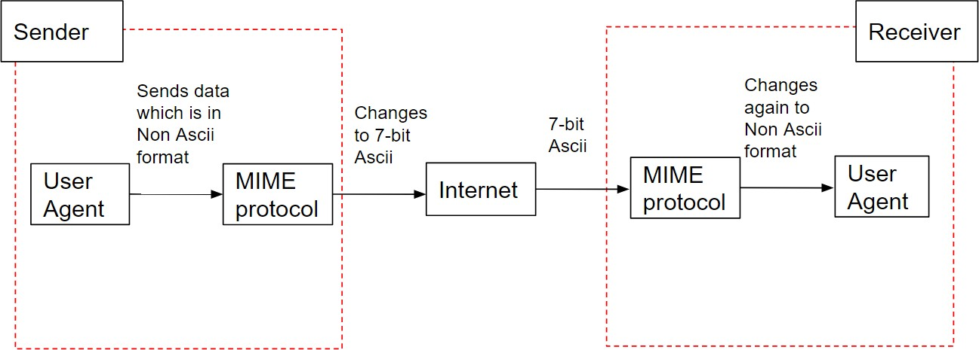

**WWW AND ARCHITECTURAL OVERVIEW**

**World Wide Web (WWW)**

* The World Wide Web or Web is basically a collection of information that is linked together from points all over the world. It is also abbreviated as WWW.
* World wide web provides flexibility, portability, and user-friendly features.
* It mainly consists of a worldwide collection of electronic documents (i.e, Web Pages).
* It is basically a *way of exchanging information* between computers on the Internet.
* The WWW is mainly *the network of pages* consists of images, text, and sounds on the Internet which can be simply viewed on the browser by using the browser software.

**Components of WWW**

The Components of WWW mainly falls into two categories:

* Structural Components
* Semantic Components

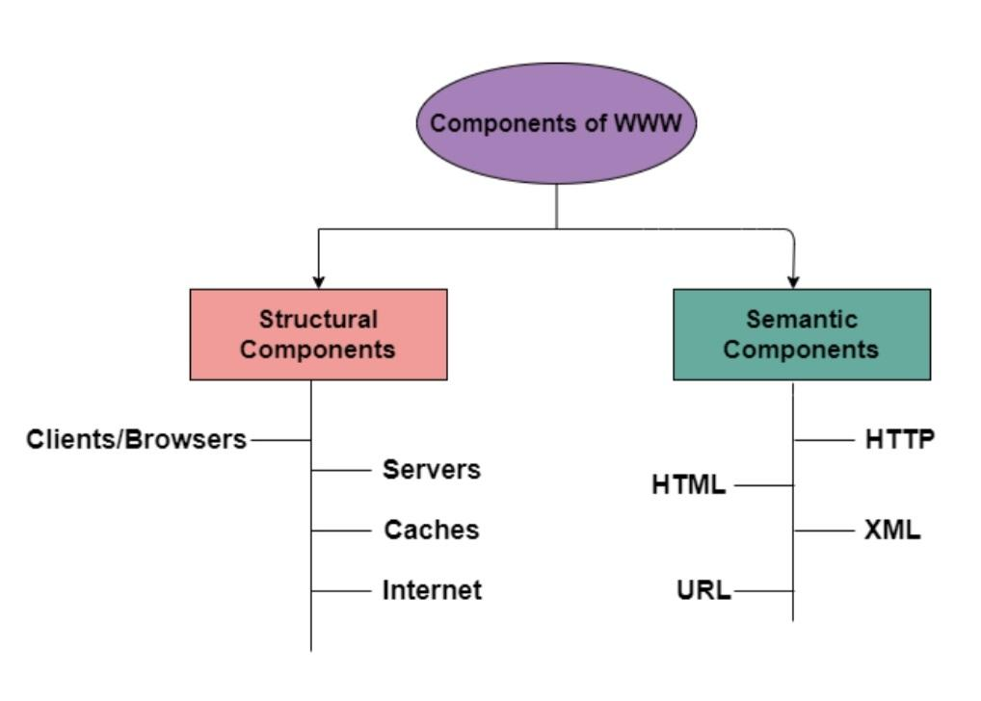

**1.Client/Browser**

* Used to communicate with the webserver on the Internet.
* Each browser mainly comprises of three components and these are:

- *Controller, Interpreter ,Client Protocols*

* The Controller - receives the input from the input device, after that it uses the client programs in order to access the documents.
* After accessing the document, the controller makes use of an interpreter in order to display the document on the screen.
* Interpreter -Java, HTML, javascript (depending upon the type of the document).

Client protocol - FTP, HTTP, TELNET.

**2. Server**

The Computer that is mainly available for the network resources and in order to provide services to the other computer upon request is generally known as the **server**.

* The **Web pages** are mainly stored on the server.
* Whenever the request of the client arrives then the corresponding document is sent to the client.
* The connection between the client and the server is **TCP.**
* It can become more efficient through **multithreading or multiprocessing.** Because in this case, the server can answer more than one request at a time.

**3.URL**

* URL is an abbreviation of the **Uniform resource locator.**
* It is basically a standard used for specifying any kind of information on the Internet.
* In order to access any page the client generally needs an address.
* To facilitate the access of the documents throughout the world HTTP generally makes use of Locators.
  + - URL mainly defines the four things:



* Protocol-to retrieve the document.
* Host Computer-the computer on which the information is located.
* Port-the port number of the server.
* Path-the pathname of the file where the information is located.

**4. HTML**

HTML is an abbreviation of **Hypertext Markup Language**

* It is generally used for creating web pages.
* It is mainly used to define the contents, structure, and organization of the web page.

**5.XML**

* XML is an abbreviation of **Extensible Markup Language.**
* It mainly helps in order to define the common syntax in the semantic web.

**FEATURES OF WWW**

* Distributed
* Open standards and Open source
* Mainly makes the use of Web Browser in order to provide a single interface for many services.
* Dynamic
* Interactive
* Cross-Platform

**Architecture of WWW**

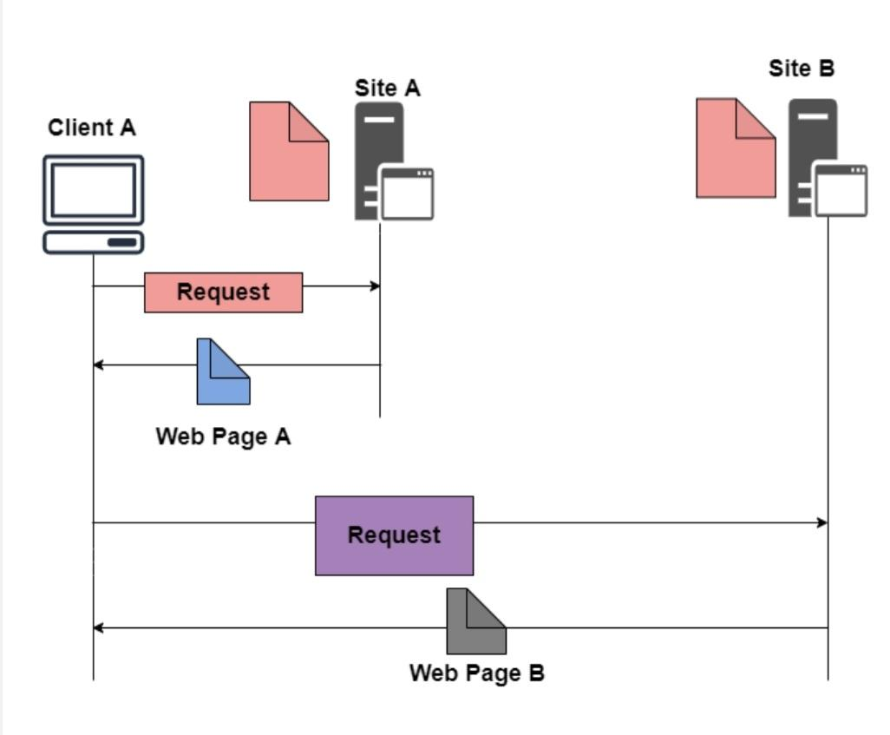

* The WWW is mainly a *distributed client/server service* where a client using the browser can access the service using a server. The Service that is provided is distributed over many different locations commonly known as *sites/websites.*
* Each website holds one or more documents that are generally referred to as *web pages*.
* Where each web page contains a link to other pages on the same site or at other sites.
* These pages can be retrieved and viewed by using *browsers*.

**ADVANTAGES OF WWW**

* It mainly provides all the information for *Free*.
* Provides rapid *Interactive way* of Communication.
* It is *accessible* from anywhere.
* It has become the *Global* source of media.
* It mainly facilitates the exchange of a *huge volume of data.*

**SNMP**

* SNMP stands for **Simple Network Management Protocol**.
* SNMP is a framework used for managing devices on the internet.
* It provides a set of operations for monitoring and managing the internet.
* SNMP provides a set of fundamental operations in order to monitor and maintain the Internet.
* It is an application layer protocol.
* This protocol is mainly used to monitor the network, detect the faults in the Network, and sometimes it is also used to configure the remote devices.
* SNMP is a framework used for managing devices on the internet.
* It provides a set of operations for monitoring and managing the internet.
* SNMP provides a set of fundamental operations in order to monitor and maintain the Internet.
* This protocol is mainly used to monitor the network, detect the faults in the Network, and sometimes it is also used to configure the remote devices.

**SNMP COMPONENTS**

SNMP's client-server architecture has the three following components:

1. SNMP manager
2. SNMP agent
3. Management information base ([MIB](https://www.techtarget.com/whatis/definition/management-information-base-MIB)).

**SNMP manager**

* The SNMP manager acts as the client
* It is also known as Network Management Station (NMS)
* It is a centralized system used to monitor network

**SNMP agent**

* the SNMP agent acts as the server
* It is a software module installed on a managed device.
* Managed devices can be network devices like PC, routers, switches, servers, etc.

**MIB**

* acts as the server's database.
* When the SNMP manager asks the agent a question, the agent uses the MIB to supply the answer.
* MIB consists of information on resources that are to be manage

**SNMP messages/SNMP COMMANDS**

1. GetRequest
2. GetNextRequest
3. **GETBULK Request:**
4. SetRequest
5. GetResponse
6. Trap.
7. InformRequest:
8. Report

**GetRequest:**

The GetRequest message is sent from a manager (client) to the agent (server) to retrieve the value of a variable.

**GetNextRequest:**

The GetNextRequest message is sent from the manager to agent to retrieve the value of next variable.

This type of message is used to retrieve the values of the entries in a table.

**GETBULK Request:**

Sent by the SNMP manager to the agent to efficiently obtain a potentially large amount of data, especially large tables.

**GetResponse:**

The GetResponse message is sent from an agent to the manager in response to the GetRequest and GetNextRequest message.

This message contains the value of a variable requested by the manager.

**SetRequest:**

The SetRequest message is sent from a manager to the agent to set a value in a variable.

**Trap:**

The Trap message is sent from an agent to the manager to report an event.

For example, if the agent is rebooted, then it informs the manager as well as sends the time of rebooting.

**InformRequest:**

Sent from one manager to another remote manager to get the value of some variables

**Report**

To report errors between managers

**SNMP messages/Commands**

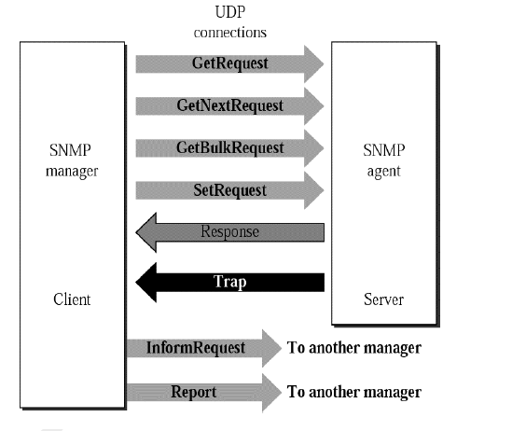

**SNMP Architecture**

* As SNMP is a client/server protocol, SNMP nodes can be classified as either clients (SNMP managers) or servers (SNMP agents).
* SNMP managers, also called network management systems (NMSs), have a more central role in the network.
* It will actively query and collect messages from SNMP agents in the network.
* The agent also has the controls on the access to the agent’s Management Information Base (MIB), MIBs are nothing but text files, and values of MIB data objects are the topic of conversation between Managers and Agents.
* MIBs describe the structure of the management data of a device subsystem; they use a hierarchical namespace containing object identifiers (OID).
* Each MIB object definition has a unique OID; the concept of OID is very similar to Modbus Register in Modbus Protocol.
* An OID consists of a dotted list of integers. For example, within the MIB of a particular UPS, the OID for data object.
* When Managers and Agents communicate, they refer to MIB data objects using OID’s.  
  An OID sent with a corresponding value {OID,Value} is referred to as “binding”.
* As SNMP agents are individual SNMP processes running on a host, multiple agents can be active on a single network node at any given time. The SNMP agent provides the interface between the manager and the physical device(s) being managed.

